**Lab Report 3**

Title: Network Analysis in ArcPro Compared to ArcGIS Online

Notice: Dr. Bryan Runck

Author: Maisong Francis

Date: 3/10/2021

**Project Repository:**[*https://github.com/msongfrancis/GIS5572.git*](https://github.com/msongfrancis/GIS5572.git)

**Abstract**

Network analysis is useful in many problems that involve routing and networks. In this scenario, the goal is to find the two best routes for two delivery vehicles making 10 stops and ending where they start with consideration to closed highways and time ranges. This analysis involves using a road network and locations of the start and delivery stops. Network analysis can be performed using ArcGIS Pro and in ArcOnline. ArcPro was able to consider all parameters. ArcOnline has some limitations regarding file size, specific delivery time windows, and network properties. However, both can compute routes for multiple vehicles that are effective with total time and total distance listed.

**Problem Statement**

Reilly and Randy must deliver 10 packages to 10 different locations. The goal is to find the best two routes for their two trucks to minimize the time they must spend working before a holiday. Highway 94 and 35W are closed for construction. They need printed out directions.

*Table 1. Requirements to solve the USPS problem.*

|  |  |  |  |  |  |  |
| --- | --- | --- | --- | --- | --- | --- |
| **#** | **Requirement** | **Defined As** | **Spatial Data** | **Attribute Data** | **Dataset** | **Preparation** |
| 1 | Road network | Road centerlines to serve as a network from | Road geometry | SPEED_LIM  Shape_length | [Mn GeoSpatial Commons](https://resources.gisdata.mn.gov/pub/gdrs/data/pub/us_mn_state_metrogis/trans_road_centerlines_gac/shp_trans_road_centerlines_gac.zip) |  |
|  | Closed Highways | Highways that can’t be traveled on | Road geometry |  | [Mn GeoSpatial Commons](https://resources.gisdata.mn.gov/pub/gdrs/data/pub/us_mn_state_metrogis/trans_road_centerlines_gac/shp_trans_road_centerlines_gac.zip) |  |
| 2 | Starting point | Address of where the delivery trucks will begin | Point |  | Google Places API |  |
| 3 | Delivery stops | Addresses for where the delivery trucks need to go to | Point |  | Google Places API |  |
| 4 | Time frames | Time frame when deliveries need to be made. |  | Time Start  Time End |  |  |

**Input Data**

The network dataset used was obtained from MetroGIS and includes the road centerlines for the metropolitan counties in Minnesota. The useful attributes that aid in the network analysis are the street names, speed limit, and length of each road feature. As for the depot and orders, the addresses were provided in the original lab instructions and coordinates were extracted using Google Places API to perform the analysis.

*Table 2. Datasets used for in the network analysis.*

|  |  |  |  |
| --- | --- | --- | --- |
| **#** | **Title** | **Purpose in Analysis** | **Link to Source** |
| 1 | Metropolitan counties Road Centerlines | Raw input dataset for routing analysis from MetroGIS and will be used to isolate closed highways as barriers | [Mn GeoSpatial Commons](https://resources.gisdata.mn.gov/pub/gdrs/data/pub/us_mn_state_metrogis/trans_road_centerlines_gac/shp_trans_road_centerlines_gac.zip) |
| 2 | Depot | Starting and ending point of deliveries | Google Places API |
| 3 | Orders | Stop locations of deliveries | Google Places API |

**Methods**

*ArcGIS Pro*

Before beginning the network analysis, specifically the Vehicle Routing Problem analysis, the network dataset for the study area must be built. I used the road centerlines for the Metropolitan counties in Minnesota and calculated the time cost by dividing the length of the road by the speed limit – which was converted to meters per second (Figure 1). This was necessary because the coordinate system units are in meters, not miles. After doing so, I created a new driving mode that considered the time cost as it’s impedance parameter. After changing these network properties, I used the Build network tool to completely build the network which has edges and junctions (Fig. 1).

*Figure 1. Network properties for the usps_ND network dataset.*

*a)*

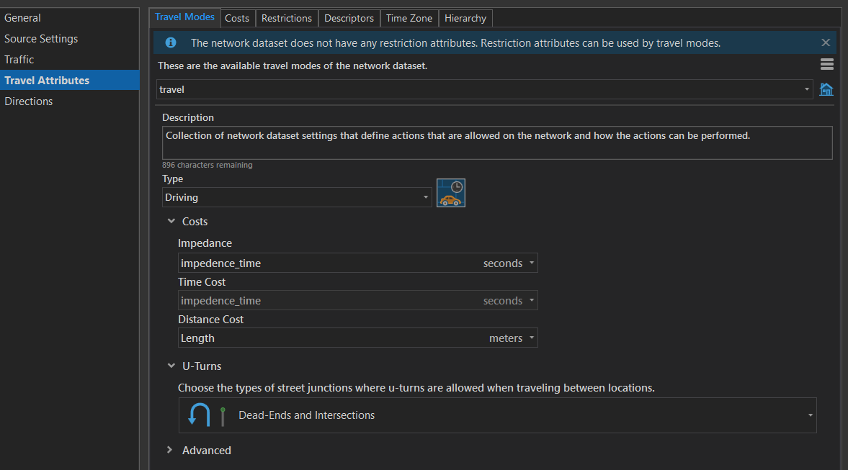

*b)*

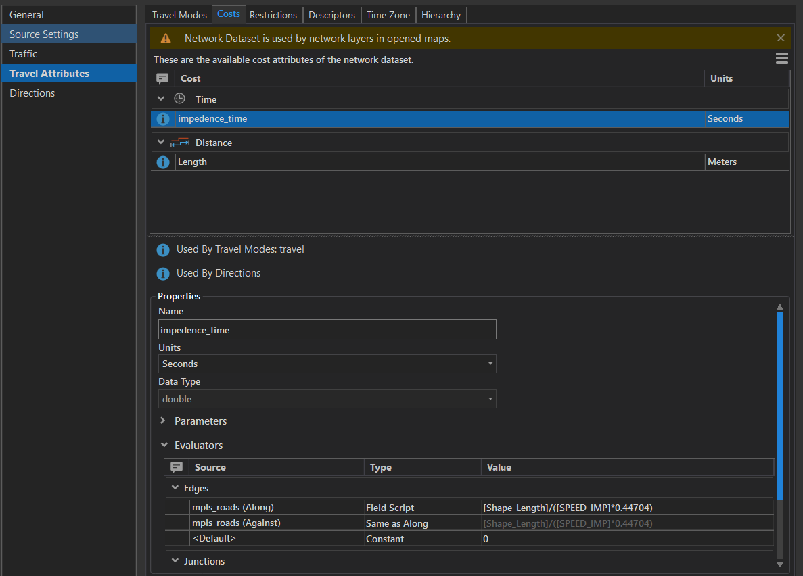

*c)*



*Figure 2. General workflow to build network dataset.*

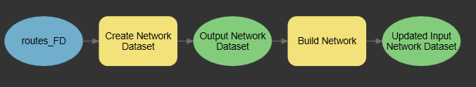

The start and stop locations were obtained using Google Places API. The coordinates were converted to points and then reprojected from EPSG 4326 to EPSG 26915. I then made a vehicle routing problem analysis layer and imported the depot (starting point), the order (stops with time intervals), and the routes. I specified that there should be two routes because there were two delivery trucks in this problem. To get two different route options, I indicated 5 maximum stops per fleet, then with 10 maximum stops per fleet. I also solved for when there was one delivery truck to see if the overall time was shorter.

To consider the closed highways, I selected out highway 94 and 35W road centerlines from the roads used to create the network dataset as my road barriers. To consider roads that went over the highway and/or were crossable, I essentially converted the road barriers to polygons as well as the open roads to polygons by buffering them 1 m. By doing this, I could erase the intersecting open roads from the highway to create passable gaps. I then imported the road barriers with the passable road gaps as a polygon barrier in my vehicle routing analysis layer. After importing these parameters and specifying the delivery windows, the Solve tool was used to calculate the possible routes for the two fleets (Fig. 3).

*Figure 3: Vehicle Routing Problem workflow*

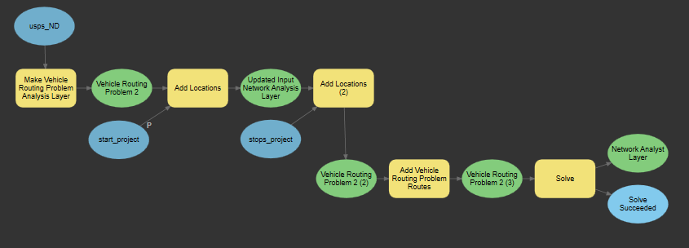

*ArcGIS Online*

I uploaded my stops and start point shapefiles to ArcGIS Online as a zipped file. Using ArcNotebooks, I used the read-to-use Place Routes analysis tool to compute the best routes (Fig.4).

*Figure 4. Workflow for vehicle routing problem in ArcGIS Online*

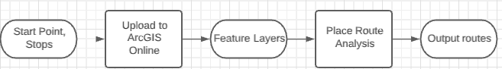

**Results**

*ArcGIS Pro*

With two delivery vehicles, there are many routes depending on the maximum stops per vehicle. These results considered the closed highways. In the first result when each vehicle has 5 stops, the first route for the first vehicle will travel 74 miles with a total time of 2 hours 25 minutes, of which there is a 53-minute wait time. The second vehicle will travel 41 miles and have a total time of 55 minutes. Collectively the two vehicles will have a total time of 3 hours 20 minutes and will travel a total of 115 miles. The maximum travel time is 2 hours 25.

In the second result for two delivery vehicles, when each vehicle could have a maximum of 10 stops, the first vehicle will travel 84 miles with a total time of 2 hours and 25 minutes of which there is a 32-minute wait time. The second vehicle will travel 11 miles and have a total time of 12 minutes. Collectively the two vehicles will have a total time of 2 hours and 37 minutes and will travel a total of 95 miles. (Fig 5).

*Figure 5. Vehicle routing problem analysis results showing the two different routes for each delivery vehicle. a) Route results when each vehicle has a maximum of 5 stops. B) Route results when each vehicle can have a maximum of 10 stops. The red line features are the closed highways. Note there are roads that can pass over, under, or between the closed highways.*

|  |  |
| --- | --- |
| a) | b) |

Lastly when there is only one delivery vehicle, the routing results show that with one vehicle it is possible to deliver to all 10 stops within a total time of 2 hours and 26 minutes with a 31-minute wait time, and a total travel distance of 89 miles.

*ArcGIS Online*

The ArcGIS Online results does not consider the highway barriers. The two routes had 5 stops each and ends at the start point. The first route for the first vehicle is 89.6 miles long and has a total travel time 116.51 (1 hour 56.51 minutes). The second route for the second vehicle is 40.17 miles long and has a travel time of 77.62 minutes. (Fig 6).

*Figure 6. Routes computed from using the Place Routes analysis in ArcGIS Online. There are two routes. The purple route is 89.6 miles long and has a travel time of 116.51 minutes. The green route is 40.17 miles long and has a travel time of 77.62 minutes.*

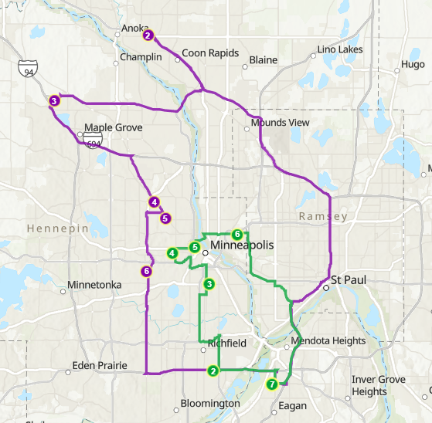

**Results Verification**

The results I expect should not have route lines intersecting with the closed highways and they should start and end at the depot. I also expect that the two vehicles will not visit the same stops. I was able to see if the results honored the barriers by seeing if the routes intersected with the input barrier. I also ensured that there were no stops being repeated in the proposed routes. Furthermore, I checked to see that Location 2 and Location 11 were delivered between 10:00 AM and 11:00 AM.

**Discussion and Conclusion**

*What did you learn? How does it relate to the main problem?*

*Comparing Network Analysis in ArcGIS Pro and ArcGIS Online*

Routing problems using ArcGIS Pro and Online are possible to solve. In ArcGIS Pro there were more capabilities such as no count limitations on barrier features and ability to create and calculate new costs associated with the network dataset. I found that ArcGIS Pro was easy to use and understand with the tutorials and documentation. The time intervals that were set for each stop were able to be honored. There was also a possibility in ArcPro to value speed over set time range for stops. However, to do network analysis, you first need to build a network dataset.

In ArcGIS Online (AGOL), there were less steps to perform network analysis. To use the Place Route analysis tool, the user did not need to make a network dataset prior. However, with that it also means you cannot customize the network dataset used in the network analysis. Furthermore, AGOL presented difficulties when considering barriers. Initially I had used line barriers for the closed highways and learned there was a 500-polyline limit. For points there are a 250-point limit and for polygons, there were not a limit. I tried to consider the barriers in AGOL notebooks, but the environment would freeze, or the tool would fail. Additionally, the results were written out to a feature layer and must be viewed using Map Viewer.

*Overall Results*

The requirement of the problem was to reduce the amount of time the two employees spend working before a holiday. Based on my results when there are two delivery vehicles, the best solution proposed above is to have one vehicle do 9 stops and the other do 1 stop. This would result in an overall total time of 2 hours and 37 minutes and total travel distance of 95 miles. (Fig 5). However, this does not consider the traffic time as discussed and could result in the first vehicle accruing delay time.

I found it interesting when there was only one vehicle considered, the result showed that the overall time would be 2 hours and 26 minutes. This is less than the time for two vehicles and they would also travel less mileage. If this is considered in a business perspective, this would be the best option because it is the least amount of time cost and the least amount of money cost in respects to having to pay one employee.

The overall results could be more accurate if the analysis considered whether a highway under construction was completely prohibited from travel or accrued more time cost.

**References**

ESRI. (n.d.-a). *arcgis.features.analysis module — arcgis 1.8.4 documentation*. Arcgis.Features.Analysis Module. Retrieved March 24, 2021, from https://developers.arcgis.com/python/api-reference/arcgis.features.analysis.html#featureinput

ESRI. (n.d.-b). *Create a network dataset—ArcGIS Pro | Documentation*. ArcGIS Pro. Retrieved March 24, 2021, from https://pro.arcgis.com/en/pro-app/latest/help/analysis/networks/how-to-create-a-usable-network-dataset.htm

ESRI. (n.d.-c). *Plan Routes—ArcGIS Online Help | Documentation*. ArcGIS Online. Retrieved March 24, 2021, from https://doc.arcgis.com/en/arcgis-online/analyze/plan-routes.htm

ESRI. (n.d.-d). *Work with network analysis layers—ArcGIS Pro | Documentation*. ArcGIS Pro 2.7. Retrieved March 24, 2021, from https://pro.arcgis.com/en/pro-app/latest/help/analysis/networks/new-network-analysis-layer.htm

ESRI. (2021). *Vehicle routing problem analysis layer—ArcGIS Pro | Documentation*. ArcGIS Pro. https://pro.arcgis.com/en/pro-app/latest/help/analysis/networks/vehicle-routing-problem-analysis-layer.htm

**Self-score**

*Fill out this rubric for yourself and include it in your lab report. The same rubric will be used to generate a grade in proportion to the points assigned in the syllabus to the assignment.*

|  |  |  |  |
| --- | --- | --- | --- |
| **Category** | **Description** | **Points Possible** | **Score** |
| **Structural Elements** | All elements of a lab report are included **(2 points each)**:  Title, Notice: Dr. Bryan Runck, Author, Project Repository, Date, Abstract, Problem Statement, Input Data w/ tables, Methods w/ Data, Flow Diagrams, Results, Results Verification, Discussion and Conclusion, References in common format, Self-score | 28 | **28** |
| **Clarity of Content** | Each element above is executed at a professional level so that someone can understand the goal, data, methods, results, and their validity and implications in a 5-minute reading at a cursory-level, and in a 30 minute meeting at a deep level **(12 points)**. There is a clear connection from data to results to discussion and conclusion **(12 points)**. | 24 | **24** |
| **Reproducibility** | Results are completely reproducible by someone with basic GIS training. There is no ambiguity in data flow or rationale for data operations. Every step is documented and justified. | 28 | **25** |
| **Verification** | Results are correct in that they have been verified in comparison to some standard. The standard is clearly stated **(10 points)**, the method of comparison is clearly stated **(5 points)**, and the result of verification is clearly stated **(5 points)**. | 20 | **20** |
|  |  | 100 | **97** |